Western Governors University
C964: Computer Science Capstone
Marisa Espinoza
Student ID: 012111614
10-16-2025

Task 2 Parts A, B, and D
Part A: Letter of Transmittal 2
Part B: Project Proposal Plan 4
Project Summary 4
Data Summary 4
Implementation 4
Timeline 5
Evaluation Plan 6
Costs 6
Part D: Post-implementation Report 8
Solution Summary 8
Data Summary 8
Machine Learning 9
Validation 9
Visualizations 11
User Guide 12
Reference Page 14

Part A: Letter of Transmittal

10-1-2025
Mary Lopez, CEO
Pet Pals
123 Dog Alley
Sacramento, CA 12345

Dear Mary Lopez,

Over the past several months, our shelter has seen an increase in dogs being returned after adoption. This is not only heartbreaking for the animals but also strains our staff and resources. Returned dogs require re-acclimation to the shelter environment, take up limited space that we could be using to take in new animals, and often face reduced chances of future adoption because potential adopters might think there is something wrong with the dog since he/she was returned.
To address this issue, I propose developing a dog adoption matching system. Potential adopters would complete a short digital form to select the traits and characteristics they value most in a dog (for example, loyal, playful, calm). Based on their responses, the system would recommend dog breeds that best align with those preferences. While the tool would not restrict adopters to the suggested breeds, it would give them realistic expectations and a clearer understanding before making a commitment.
The solution will bring several benefits to our shelter. Most importantly, it will help lower the number of returned dogs, reducing stress for both the animals and the staff. It will also improve how we use our resources, allowing staff to focus more on rescuing and caring for new intakes instead of managing returns. Ultimately, this will lead to better adoption outcomes and give more dogs the chance to find loving, lasting homes.
Implementation would involve setting up digital kiosks in the shelter for adopters to use. The data source for dog breed traits is freely available, keeping data costs minimal. Main expenses will involve initial development of the tool and purchasing a small number of tablets for the kiosks. The estimated cost of development and equipment is $14,000. Ongoing maintenance and hosting costs are expected to be around $1,400 per year. This project will take approximately five to six weeks from start to finish for development, testing, and staff training. We will follow a clear, step-by-step development process, beginning by defining the project requirements. Then we will design how the system will look and function. Once the design is finalized and approved, we will move into development, where the tool will be coded and tested to make sure it works correctly. After that is successful, we will launch the system in the shelter and provide staff training to make sure everyone is comfortable using it.
With a background in computer science and experience working with data analysis and application development, I am confident that I can successfully lead this project and collaborate with our team to ensure smooth adoption and use.
This system aligns with our mission of promoting responsible pet ownership and protecting the well-being of animals in our care. I kindly ask for your approval to move forward with this project.

Sincerely,
Marisa Espinoza
Marisa Espinoza, Adoption Coordinator

Part B: Project Proposal Plan

Project Summary
Pet Pals is a city-funded, no-kill animal shelter that operates on a limited budget and relies heavily on volunteer staff. Like many community shelters, it faces ongoing challenges with space, staffing, and resource allocation. In recent months, Pet Pals has experienced an increase in the number of dogs returned after adoption, which further strains its capacity. Limited space and staffing resources make it difficult to accommodate new dogs, while the emotional impact on the returned dogs themselves is significant.
To address this, a recommendation application will be developed that allows potential adopters to select preferred dog traits and receive a ranked list of breeds that best match their preferences. The deliverables will include a fully functional application with a user-friendly interface and a user guide that details installation and usage. By providing adopters with better insight into which breeds align with their lifestyle and expectations, the application will reduce the likelihood of dogs being returned and allow staff to allocate resources more efficiently.

Data Summary
The data for this project will come from Kaggle, an open-source platform that provides publicly available datasets. The dataset will include detailed information about many different dog breeds, such as their size, lifespan, fur colors, temperaments, and common health traits. Once obtained, the data will be reviewed and prepared so it can be used in the application. This preparation will include removing duplicate or incomplete entries and ensuring that all breed traits are presented in a consistent format.
During development, the data will be organized in a way that allows it to be used for both visualizations and for building the recommendation application. The visualizations will help users and staff understand patterns in the data, such as which traits are most common among breeds or how certain traits relate to breed size. The processed data will also allow the recommendation tool to identify breeds that most closely match an adopter’s selected preferred traits.
This dataset is well-suited for the project because it provides a wide range of breed characteristics that directly relate to adoption preferences. Since the data is publicly available and contains no personal information, there are no ethical or legal concerns with its use.

Implementation
The project implementation will follow the Waterfall methodology because it provides a structured, linear process that aligns well with the project’s straightforward goals. This approach ensures that each stage of the project is wrapped up and validated before moving on to the next, minimizing changes and errors and maintaining a clear workflow (Waterfall methodology — project management, 2025).
The project will be divided into five main phases. First, the requirements phase will define exactly what is needed to complete the project, including identifying the data source, necessary preprocessing steps, and the desired outputs. Next, during the design phase, the overall layout of the application and user interface will be planned. This includes determining how users will interact with the app, how data will flow through the system, and how the visualizations will be presented. After that will be the implementation phase. This is when the design will be translated into code. The dataset will be retrieved and processed, the machine learning model will be applied, and the visualizations and dashboard will be created. Once this is done, we will begin the testing phase. We will verify that the application runs as expected and provides accurate results. Finally, in the deployment and maintenance phase, the completed application will be deployed, and ongoing maintenance will ensure that it remains running and up to date as new data or breed information becomes available.

Timeline
Milestone or deliverable | Project Dependencies | Resources | Start and End Date | Duration
Project proposal and approval | None | Research materials | 10/13-10/20 | 1 Week
Define the application requirements | Approved proposal | Stakeholder input, project proposal | 10/20-10/27 | 1 Week
Design the application and get approval | Requirements defined | Design mockup tools, feedback from stakeholders | 10/27-11/10 | 2 Weeks
Code and implement the application | Approved design | Kaggle dataset, VS Code, Python, Jupyter Notebook, pandas, plotly, ipywidgets, scikit-learn, IPython | 11/10-11/17 | 1 Week
Test and verify the application | Application implemented | Debugging tools, test data, user feedback | (1 week break for Thanksgiving)  11/24-12/1 | 1 Week
Deploy the live application | Successful testing | Voila, documentation files | 12/1-12/8 | 1 Week
Train Staff | Live application | User guide | 12/8-12/15 | 1 Week

Evaluation Plan
At each stage of development, we will verify that we are meeting the established requirements of the application. During the design phase, we will review our documentation and ensure that all planned features align with the project’s objectives. During implementation, we will perform code reviews and test each component to verify that it works correctly before moving to the next phase.
Integration testing will then be conducted to ensure that all parts of the application work together as intended. Once the application is complete, we will validate both the machine learning model and the overall application. The model’s outputs will be assessed to ensure that the recommended breeds align with user-selected traits and provide reliable suggestions.
Lastly, we will perform user testing on the final application to confirm that it is functional, user-friendly, and meets all project goals. Feedback from stakeholders will be gathered to confirm that the solution meets both technical and operational expectations.

Costs
Item | Description | Quantity | Unit Cost | Total Cost
Development Software | VS Code (Free, version 1.103.2 | 1 | $0 | $0
Development Software | Jupyter Notebook (Free) | 1 | $0 | $0
Development Software | Python and Libraries (Free) | 1 | $0 | $0
Dataset | Dog breeds and traits CSV from Kaggle | 1 | $0 | $0
Hardware | Tablets for kiosks | 3 | $350 | $1050
Labor | Planning, Designing, Development, Testing, Training (1 employee) | ~200 hrs. | $65/hr. | $13,000
Deployment / Hosting | Cloud hosting for the dashboard and application | 12 months | $50/month | $600
Maintenance / Updates | Ongoing labor for bug fixes and data updates | 12 months (approximately 1 hr. per month) | ~$65/month | $780

Part D: Post-implementation Report

Solution Summary
Pet Pals has experienced an increase in dogs being returned after adoption, which creates emotional distress for the animals and reduces staff efficiency. This issue often arises when adopters select dogs whose temperaments or traits do not align with their lifestyles or expectations.
The developed application addresses this problem by providing a recommendation tool that matches potential adopters with dog breeds based on their preferred character traits. Users can select the qualities they want in a dog, and the application identifies breeds that most closely align with those preferences. This helps adopters make more informed decisions, improves adoption satisfaction, and supports staff in managing resources more effectively.
The project’s hypothesis proposed that implementing this recommendation tool would help reduce the number of returned dogs by improving adoption compatibility. While the application has not been in use long enough to measure significant changes in return rates, early feedback indicates that the tool is achieving its intended purpose. Many adopters have reported that the system helped them identify breeds that better fit their lifestyles and made them more aware of what type of dog would be most suitable for them. These initial results support the hypothesis that the application contributes positively toward improving adoption outcomes and reducing returns over time.

Data Summary
The dataset was retrieved directly from Kaggle, a website that provides open-source datasets. The data was downloaded as a CSV file containing a list of over 100 dog breeds along with their corresponding descriptive traits, such as size, lifespan, fur colors, temperaments, and common health traits. After downloading, the data was imported into the project using the pandas library in Python. During the design phase, the dataset was structured to support both data visualization and a machine learning recommendation model. This included planning how to organize the data into meaningful categories, such as grouping dog breeds by size using the height data, so that patterns can be easily visualized. It also involved determining how to represent each breed’s traits in a way that could be processed numerically for similarity comparison.
During development, the data was cleaned to remove duplicate dog breeds and standardize the format of the character traits to ensure consistency across all entries. The traits were then extracted into a separate DataFrame and one-hot encoded, which means each trait was converted into a binary value that indicated whether each breed possessed that trait (One Hot Encoding in Machine Learning, 2025). This new DataFrame was then merged back with the main breed dataset. The processed data was used to create visualizations, including the most common traits overall, the most common traits by size category, and a trait co-occurrence heatmap, which shows how often two traits occur together across breeds. The data was also used to build the recommender tool, which matches user-selected traits with the most similar breeds using cosine similarity.
For maintenance, the data processing workflow was designed to be reusable. If a new or updated dataset is downloaded in the future, it can easily be reloaded into the notebook. The same cleaning, transformation, and encoding steps can be re-applied automatically to prepare it for use in the application.

Machine Learning
The model used in the application is cosine similarity. This method measures how similar two vectors are by calculating the cosine of the angle between them (Thomaz, 2023). In this project, each dog breed was represented as a binary vector, with 1 meaning the trait is present and 0 meaning the trait is not. The cosine similarity value ranges from 0 to 1. The closer the cosine similarity value is to 1, the more closely a breed matches the traits selected by the user. For example, if a user selects the traits loyal, friendly, intelligent, and energetic, the breed with the highest similarity is the Labrador Retriever with a cosine similarity score of 0.894. This indicates that the Labrador Retriever closely matches the user’s selected traits, which makes sense given that the dataset lists this breed’s traits as loyal, friendly, intelligent, energetic, and good-natured.
The cosine similarity model was implemented by converting the one-hot encoded dataset into numerical vectors, where each column represented a trait and each row represented a breed. The model then computed the cosine similarity between the user’s selected trait vector and every breed vector in the dataset using the scikit-learn library in Python. The breeds with the 10 highest similarity scores were returned as the top recommendations. This process was developed in Jupyter notebook so it can dynamically calculate similarity for any new input traits.
Cosine similarity was chosen because it was simple to implement, yet well-suited for categorical data where the goal is to measure shared features rather than distance between them (Cosine Similarity, 2025). Cosine similarity focuses on the direction of the vectors, which makes it ideal for comparing whether certain traits are present or not in each dog breed.

Validation
The algorithm for this project falls into the unsupervised learning category, which means it works independently to uncover patterns or similarities directly from the input data without any specific guidance or instruction (Supervised vs. unsupervised learning, n.d.).
The model uses cosine similarity to measure how closely a user’s preferred dog traits align with traits of different dog breeds and then returns a ranked list of recommended breeds.
Unlike supervised methods that learn from labeled examples that provide the desired output values, this approach finds similarities and groupings directly from unlabeled data (Supervised vs. unsupervised learning, n.d.; What is Unsupervised Learning?, 2025). To validate the performance of this unsupervised model, breeds are grouped using a clustering algorithm, and the resulting structure is evaluated using the silhouette coefficient. The silhouette coefficient has a range of -1 to 1 and measures how well each breed fits within its assigned cluster compared to other clusters. A value close to 1 indicates that the clusters are dense and well separated, and a negative value indicates overlapping clusters (2.3. Clustering — scikit-learn 1.7.2 documentation, n.d.). In testing, the model achieved a silhouette score of approximately 0.6967, indicating that it can consistently group breeds with similar characteristics while keeping distinct breeds separate. This suggests that the model produces accurate and meaningful recommendations when matching user-selected traits to similar dog breeds.

Visualizations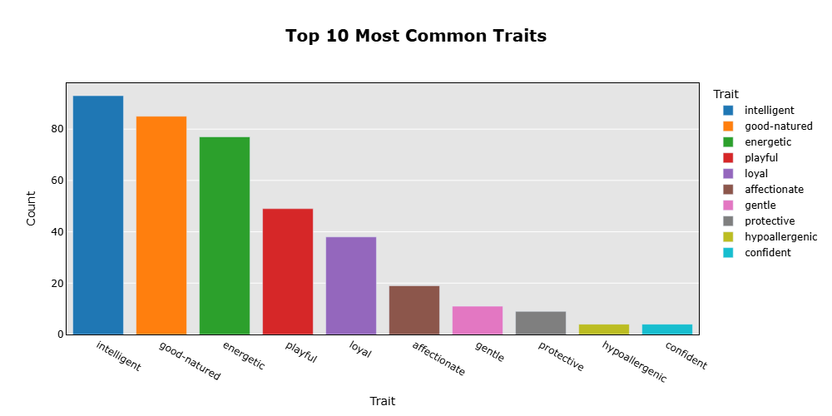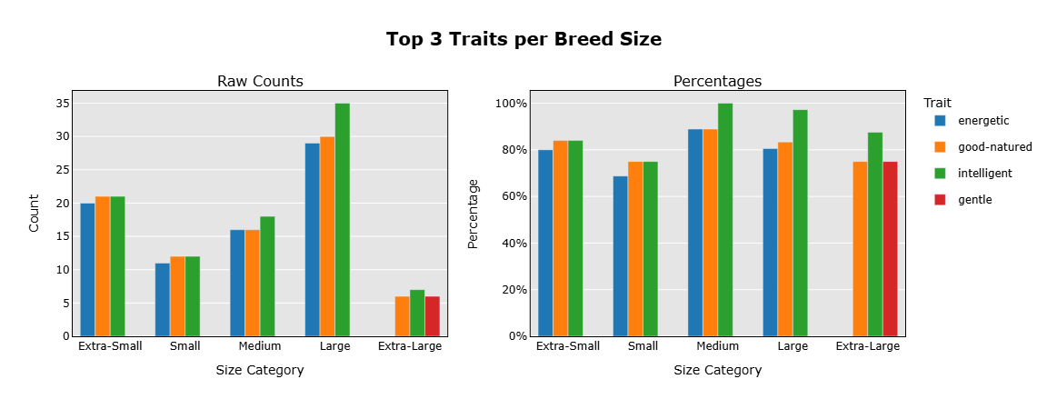

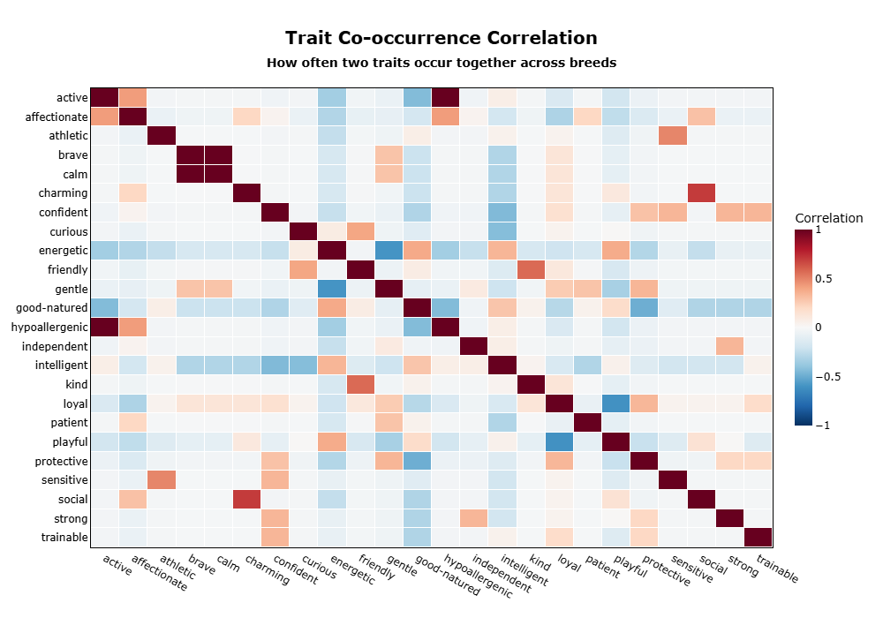
The three visualizations can also be viewed interactively within the dashboard by running the application following the User Guide below. In the application, users can hover over each chart to explore detailed values and insights.

User Guide
The following application files are provided in a ZIP file for the client to properly run the application:
- dog_breeds.csv – This is the data file
- app.ipynb – This is the Jupyter Notebook that contains the source code
- requirements.txt – This is a list of required packages that need to be installed to run the notebook
User Guide
- Download and extract the ZIP folder with the project files.
- Open the project folder in your IDE.
- Open a new terminal by typing Ctrl + `.
- In the terminal, type pip install -r requirements.txt to install the necessary packages.
- Once that’s completed, type voila app.ipynb in the terminal. A new browser window will open to the application, where you can navigate through the dashboard.
- Scroll down to the bottom of the application, and you will find checkboxes with various character traits. Select at least one character trait and click on the submit button to see the results.

Reference Page
2.3. Clustering — scikit-learn 1.7.2 documentation. scikit-learn. (n.d.). https://scikit-learn.org/stable/modules/clustering.html
Adobe. (2025, May 23). Waterfall methodology — project management. Adobe for Business. https://business.adobe.com/blog/basics/waterfall
GeeksforGeeks. (2025, July 15). Cosine Similarity. GeeksforGeeks. https://www.geeksforgeeks.org/dbms/cosine-similarity/
Google. (n.d.). Supervised vs. unsupervised learning. Google Cloud. https://cloud.google.com/discover/supervised-vs-unsupervised-learning
One Hot Encoding in Machine Learning. GeeksforGeeks. (2025, July 11). https://www.geeksforgeeks.org/machine-learning/ml-one-hot-encoding/
Thomaz, J. (2023, September 17). Math for DEVS - cosine similarity in Python. DEV Community. https://dev.to/josethz00/math-for-devs-cosine-similarity-in-python-2524
What is Unsupervised Learning?. IBM. (2025, July 22). https://www.ibm.com/think/topics/unsupervised-learning

